

**LIVE PROJECT**

**MACHINE LEARING**

**EVENT - RECOMMENDATION SYSTEM**

**PROJECT MANAGER: Jayanth G S**

**PROCESS OWNER:KEVAL SHAH**

**Contents:**

1. Objective………………………………………………………………………2

1. Introduction………………………………………………………………….3
2. Software / Hardware used…………………………………………….4
3. Data Flow Diagram………………………………………………………..4
4. Code……………………………………………………………………………..5
5. Output………………………………………………………………………….8
6. Conclusion……………………………………………………………………8

**Objective:**

This project will provide solution of making a robust recommender system that will help cloud counselage to invite its employees/interns to be in the events that he/she is interested in, as mentioned in preferences. This will also help organization to save their resources and time. This system will help organization to make all the right resources available to right people.

**Introduction:**

I have created this event recommender system for Cloud Counselage Pvt. Ltd. Which recommends the names of the employees for the events so that the HR can easily send the emails/invitations to the concerned employee/intern. This recommendation is based on the interest of the employee/intern in the particular domain and their preferences for the events which is input as a dataset to the system. This recommender system is based on Machine Learning model which uses python language and numpy, pandas, sklearn libraries. The detailed workflow of the system is described below point wise:

1. Import libraries pandas, numpy, sklearn
2. Import dataset of sentences
3. Data wrangling/cleaning
4. Apply pipeline and do CountVectorizer, tfidvectorizer, SGD classifier algorithm to train data and prepare model
5. Test the data on same model
6. Save dataset with pickle
7. Take custom input and predict corresponding output
8. Search for the names in the company provided dataset
9. Finally store them in csv file

**Software / Hardware used:**

**Software:**

Operating System: Windows.  
Internet Browser: Chrome, Mozilla Firefox, Internet Explorer.  
IDE: Jupyter Notebook

**Hardware:**

RAM: 512 MB or more.  
Processor: Pentium – IV onwards.  
Hard Disk Space: 40 GB or more.  
Server: Microsoft Windows Server 2019 Base ami-04a0ee204b44cc91a  
Microsoft Windows 2019 Datacenter edition. [English]

**Data Flow Diagram:**

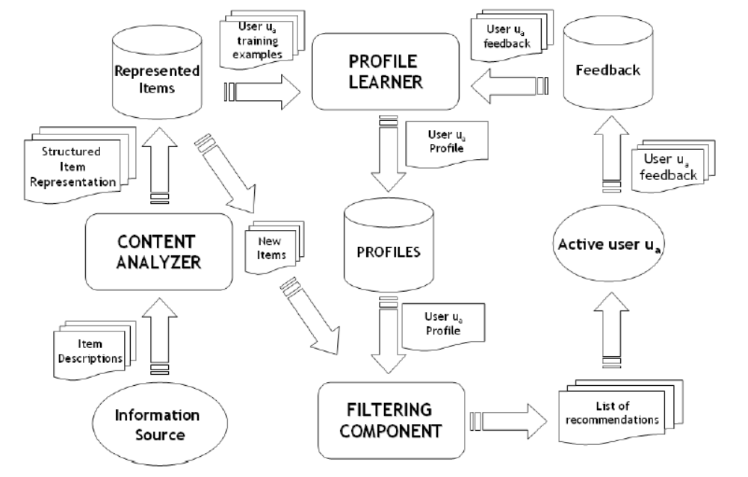

**Dataset**

Provide by cloud counselage

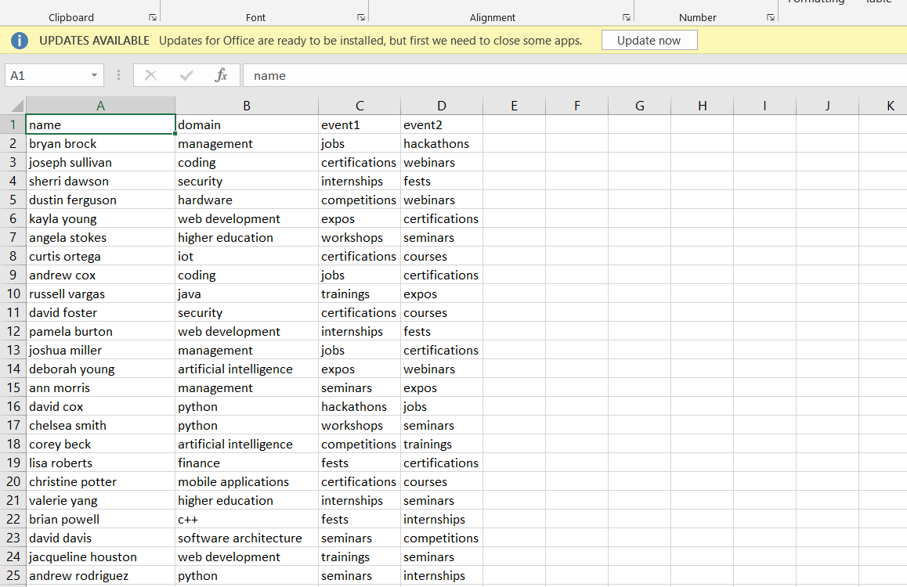

**Dataset for domains**

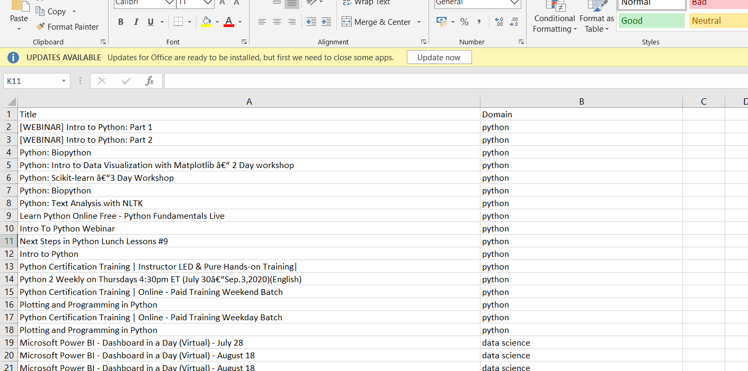

**Dataset for events**

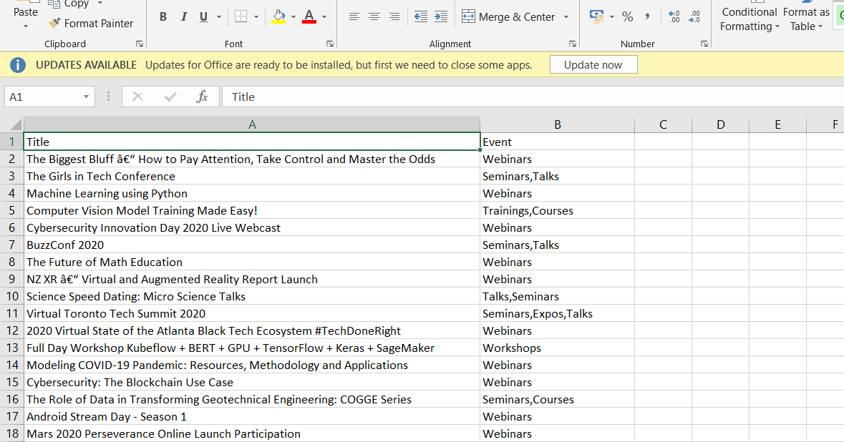

**Codes**

**For Model Training**

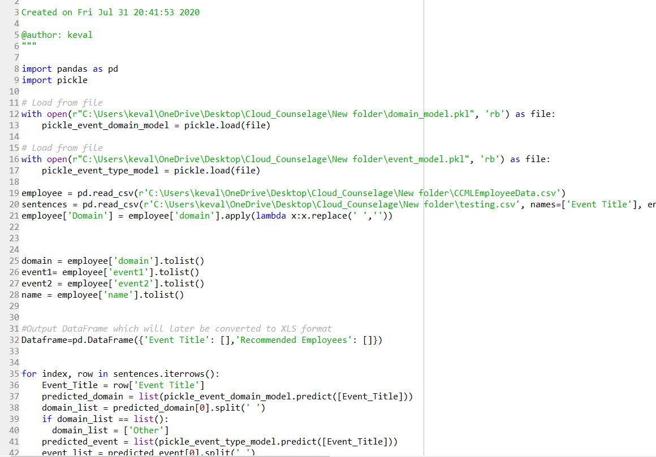

**For Employee Prediction**

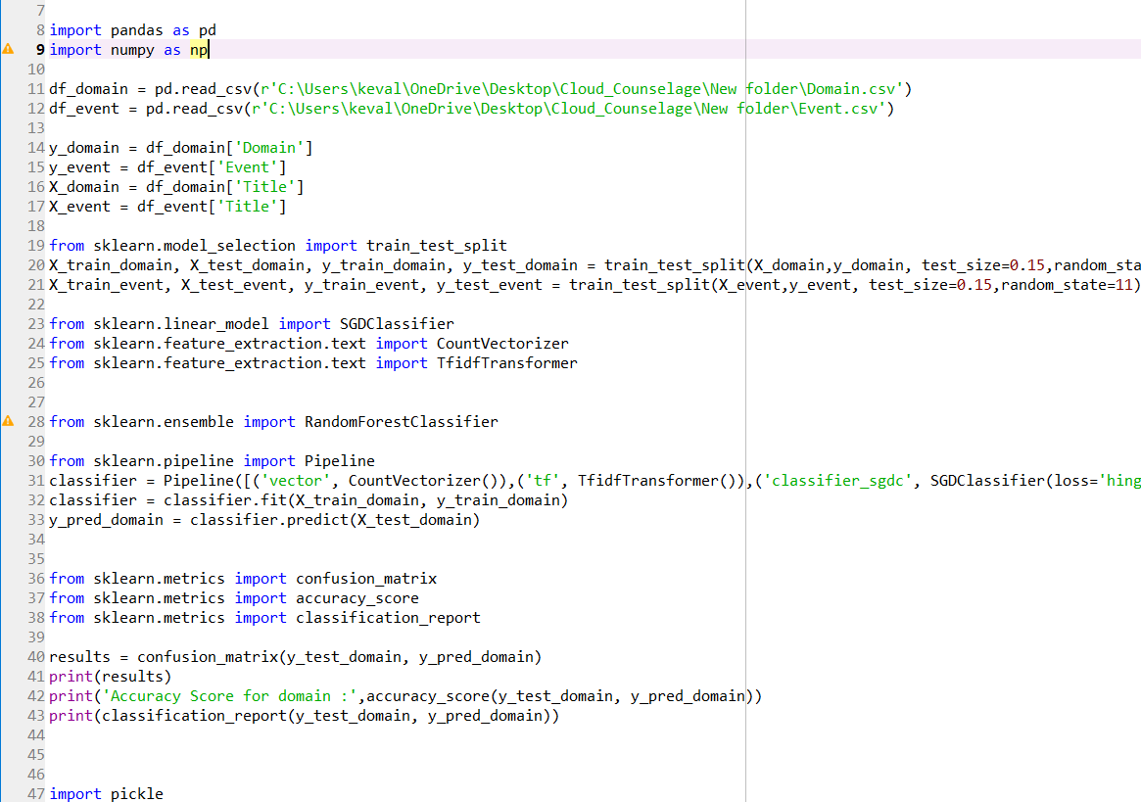

**Final output**

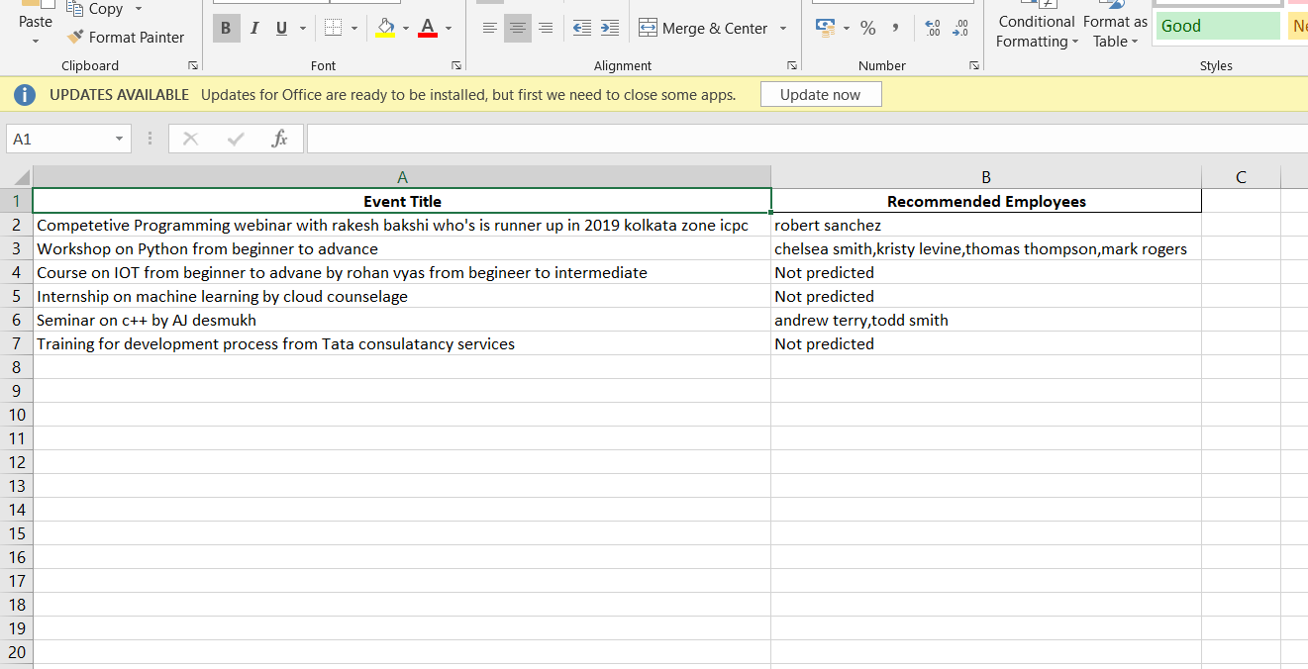

Thus after training the model from the dataset and predicting we get following ouptut

**Conclusion:** Thus I have successfully implemented the Event Recommendation System and generated the output as result.xlsx which contains events name with the employees recommend on right side using Machine Learning.